

*BAHIRDAR INSTITUTE OF TECHNOLOGY*

*SOFTWARE ENGINEERING OPERATING SYSTEM*

*INDIVIDUAL ASSIGNMENT*

*NAME : HAREGEWEYN ATAKLT REDA*

*ID NUMBER : BDU1601704*

*SECTION : A*

Operating System: syllable operating system

Submitted to: wendimu Baye

**CONTENTS PAGE**

**1.Introduction……………………………….…………….3**

**2.Objective.………………………….…………………….4**

**3.Requirments .…………………………………………..5**

**3.1.Hardware requirment………………………..6**

**3.2.Sofetware reqequirment……………………..6**

**4. Installation step……………………………….…..…….7**

**4.1.Download and install vertual box ………………8**

**4.2. Downloaded Syllable OS…………………………9**

**4.3.downloaded 7Zip ………………………….………11**

**4.4.extracting the ISO…………………………………12**

**4.5.Installed Syllable OS on VirtualBox…………..…13**

**4.6.booted the virtual machine………………………..14**

**4.7.Partition and included the AFS extension……….15**

**4.8.rebooted the virtual machine………………………17**

**5. Issues (problem faced)……………………………………..19**

**6.Solution………………………………………………………20**

**7. Filesystem support…………………………………………21**

**8. Advantage and disadvantage……………………………….23**

**8.1 advantage ……………………………………...…….23**

**8.2 disadvantage………………………………..………..24**

**9.Future outlook/recommendation……………………..……..25**

**10.Conclusion……………………………………………………26**

**11.What,How and Why Virtualization in Modern OS………27**

12.**Implement system call………………………………………35**

**Documentation for installation of syllable operating system**

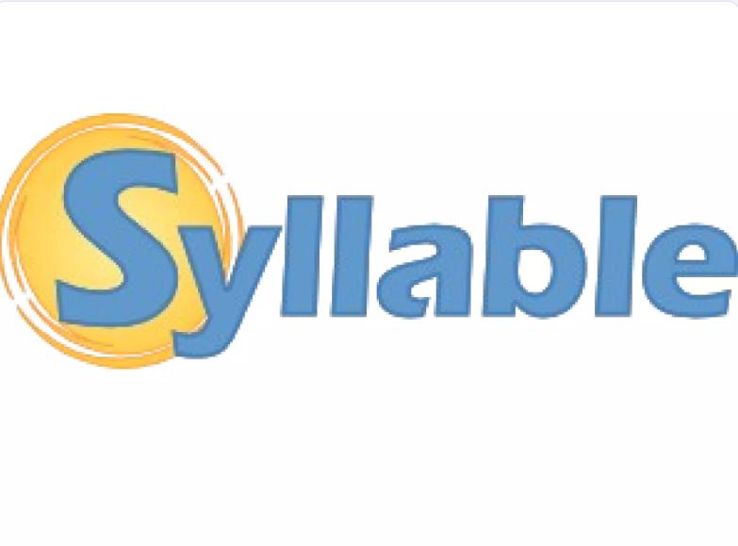

a*. Introduction (background, motivation)*

Introduction:

In the early 2000s, when mainstream operating systems grew complex and resource-hungry, a group of developers set out to create a lightweight, easy to use alternative. With this idea, Syllable OS was created in July 2002 as a fork of the dormant AtheOS operating system. AtheOS, initially developed by Kurt Skauen in the 1990s, was meant to be an AmigaOS clone on x86 PCs but evolved into its own unique system.

Syllable OS was developed as a free and open-source desktop operating system that was particularly designed for home and small office users. Its development was driven by the desire to develop a stable, efficient, and user-friendly platform that would operate on modest hardware. The operating system featured a native graphical user interface, its own kernel, and simple applications like a web browser and email client.  
 • ***Motivation***

One of the motivations for Syllable was to maintain the speed and ease of use of AtheOS but create an environment for more open development. Unlike its forerunner, Syllable opened the doors to community contributions and aimed to gain strength through collaboration. This enabled numerous open-source aspects to be integrated and to make a POSIX-compatible system, enabling more applications to be more easily ported.  
  
Although active Syllable OS development has slowed over the years, it still holds significance.It continues to be a demonstration of the power of community-driven development and the enduring popularity of minimalist, user-centric operating systems.

*b.Objectives*

Objectives of Syllable OS  
Syllable OS was created with the aim of creating a light, easy-to-use, and fast operating system for home and small office users. The objectives center on simplicity, speed, and open-source availability, thereby making it a more suitable alternative to mainstream operating systems.  
  
1. Lightweight and Fast Performance  
  
Designed to be extremely responsive and fast, Syllable OS is built on efficiency and minimal resource usage. Its lightweight architecture ensures that the system remains snappy, even on old machines, bringing new life to aging hardware.  
  
2. User-Friendly Interface  
  
Syllable OS has a graphical user interface, and individuals who are not technologically advanced can utilize it. It is an intuitive user interface that is also easy and simple to use, and it provides users with an easy experience performing everyday computing activities.  
  
3. Open-Source and Community-Driven  
  
As Syllable OS is an open-source project, it promotes community involvement and contribution. With its open-source nature, it fosters innovation and provides the guarantee that the operating system develops to meet the needs of the users.  
  
4. POSIX Compliance  
  
Syllable OS adheres to POSIX standards, thus it can be used on a wide range of software and hence makes it easier for developers to develop applications. POSIX compliance makes the system flexible and highly integrated.

5. Sustainable Computing  
  
Through performance conservation and reduced system requirements, Syllable OS promotes sustainable computing behavior. It allows one to make hardware more productive, thus lesser electronic waste.  
  
In short, Syllable OS aims to provide a fast, easy-to-use, and open-source operating system that suits the needs of home and small office users and promotes sustainable computing practices.

1. Requirements
2. Hardware Requirements

1. Processor  
We will need a supporting x86 or x86-64 CPU to boot Syllable. Both 32-bit and 64-bit are supported, so one can use it on almost all hardware.

1. Memory (RAM):

256 MB of RAM is required for minimal usage.but in order to feel smoother and for more multitasking,aiming 512 MB and above is best.

1. Storage

we’ll need at least 1 GB of free disk space to install Syllable. While that’s enough for the OS itself, having additional space is a good idea for installing extra applications and storing our data.

4.Graphics  
A video card that supports VESA or framebuffer is necessary. Syllable is designed to work with various graphics cards, although compatibility may vary, so it's worth checking if ours is supported.

5. Input Devices  
Standard input devices like a keyboard and mouse are essential to interact with and navigate the operating system.

6. Network  
An Ethernet or wireless network card will be employed for internet access. This will allow we to have access to updates and online resources, enhancing our overall experience.

ii. Software Requirements  
 1. Boot Loader  
For booting Syllable, we'll need a compatible boot loader, like GRUB or  
SYSLINUX. This is required for booting the operating system from our disk.

2. File System Support  
Syllable supports its own file system, which it primarily uses, as well as FAT and ext2 file systems. This simplifies it for we to have access to a variety of storage devices without hassle.

3. Applications

While Syllable supports some built-in applications to start we, we might want  
to contribute to our arsenal. It's fine to load open-source software which Syllable can natively run  
to enhance our pleasure.

4. Drivers  
In order for all this to work seamlessly, we'll also require fundamental drivers for our hardware components equipment, i.e., graphics, network, and sound. These drivers facilitate proper communication between the OS and our hardware.

5. Development Tools  
If we have a desire to develop or modify software, we'll need the corresponding  
development libraries and tools. This includes compilers and integrated development environments (IDEs) that work efficiently in the Syllable environment.

6. Network Protocols  
Basic network protocols like TCP/IP are supported for internet connectivity. we'll need compatible network setup software to set everything up properly.

**d. Installation steps:**

**How to Install Syllable Operating System**

There are two methods of installing Syllable OS.

1.The first is the direct installation of Syllable OS on actual hardware.

2.The second method is installing Syllable OS within a virtual machine.

I have installed it using the second method.

**Steps of Installing Syllable Operating System within a virtual machine**

I first installed and downloaded Oracle VirtualBox on Windows:  
  
 I went to the Oracle VirtualBox website.  
  
 I clicked on the Downloads page to start the download process.  
  
 I selected the Windows version and clicked to download it.  
  
 I saved the installation file on my computer.  
  
 I installed Oracle VirtualBox on Windows:  
  
 I double-clicked the downloaded setup file to run it.  
  
 I went through the installation wizard steps:  
  
 I clicked "Next" to continue.  
 I selected installation options, such as location and features.  
  
 I consented to any prompt to allow VirtualBox to set up network interfaces.  
  
 I clicked "Install" and waited for the process to complete.  
  
 I clicked "Finish" to finalize the installation.  
  
 I launched Oracle VirtualBox on Windows:  
  
 I launched VirtualBox from the start menu or desktop icon.  
  
 The VirtualBox Manager appeared, allowing me to create and manage virtual machines.

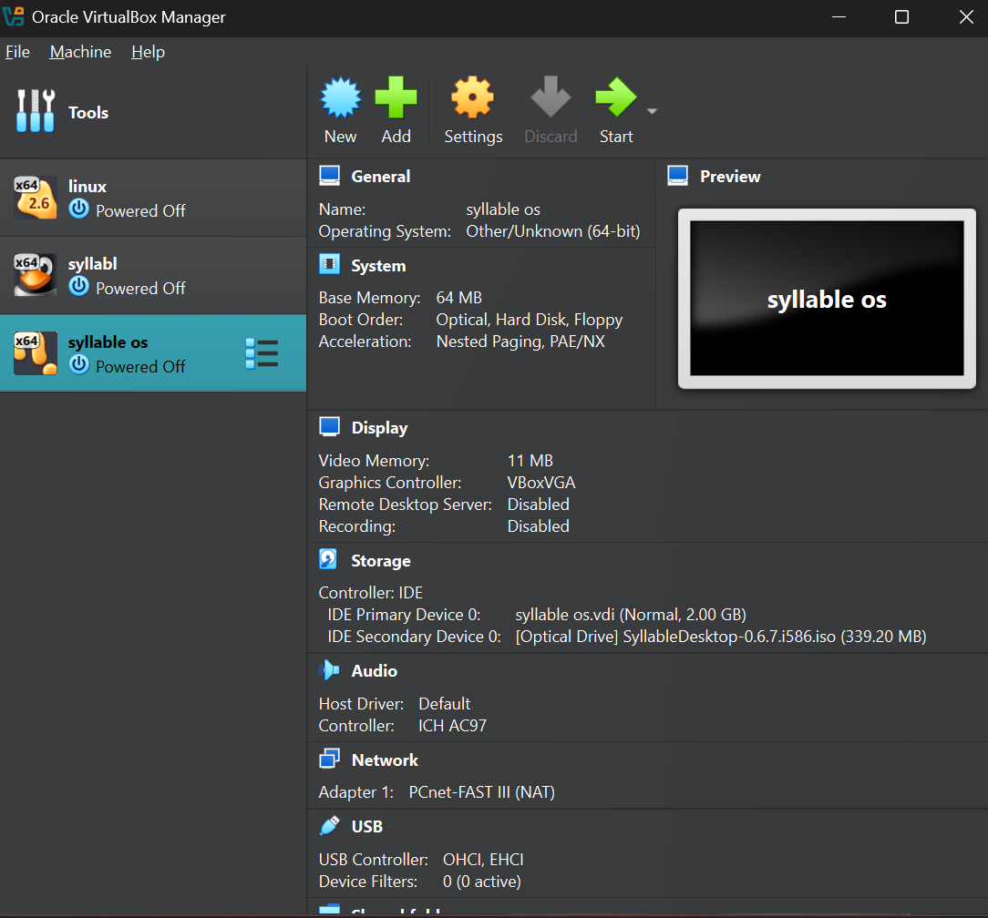

**After that, I downloaded and installed Syllable OS.**

I  Downloaded Syllable OS

I navigated to the official website of Syllable OS or a trusted site where the operating system can be downloaded.

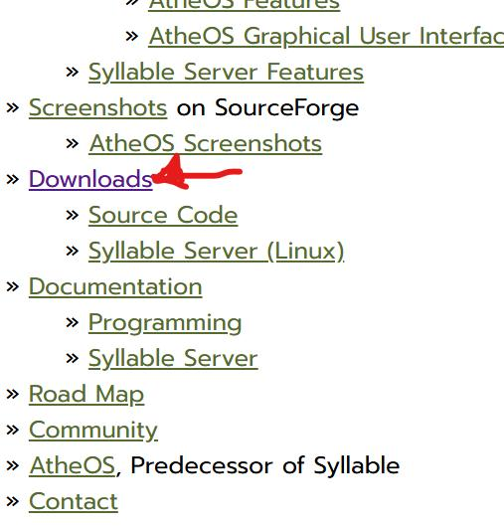

I downloaded the latest stable version of Syllable OS and selected the appropriate file .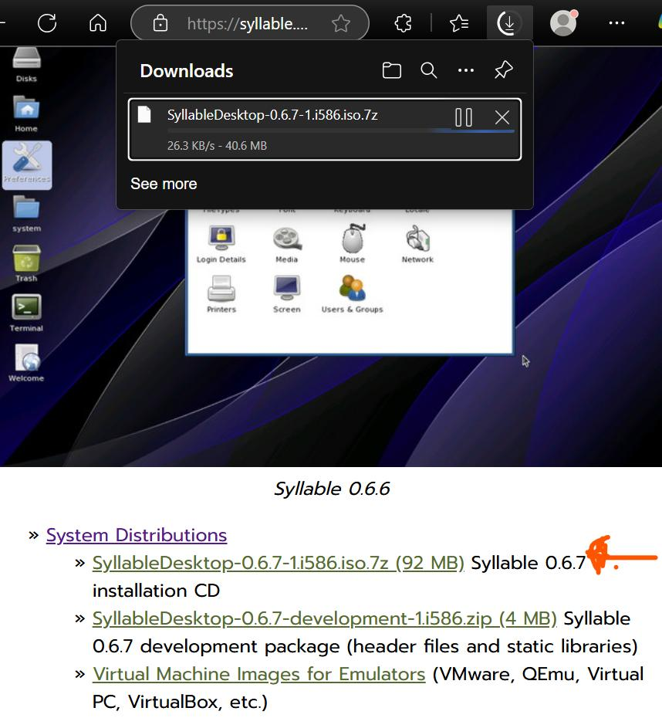  
I opened the download link and waited for the file to download to my computer.  
  
After the download was complete, I verified the file to ensure it had downloaded properly.

After I Downloaded the Syllable OS ISO File and Extracted It with 7-Zip

I downloaded 7Zip onto my machine

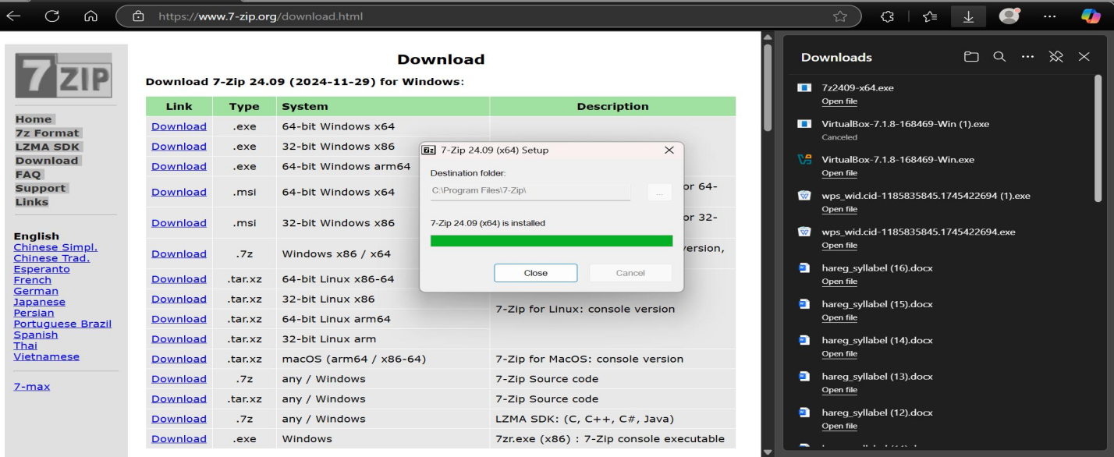I located the downloaded Syllable OS ISO file in my Downloads directory or wherever I had placed it.  
  
I right-clicked on the ISO file and selected "7-Zip" → "Extract Here" or "Extract to [Folder Name]".

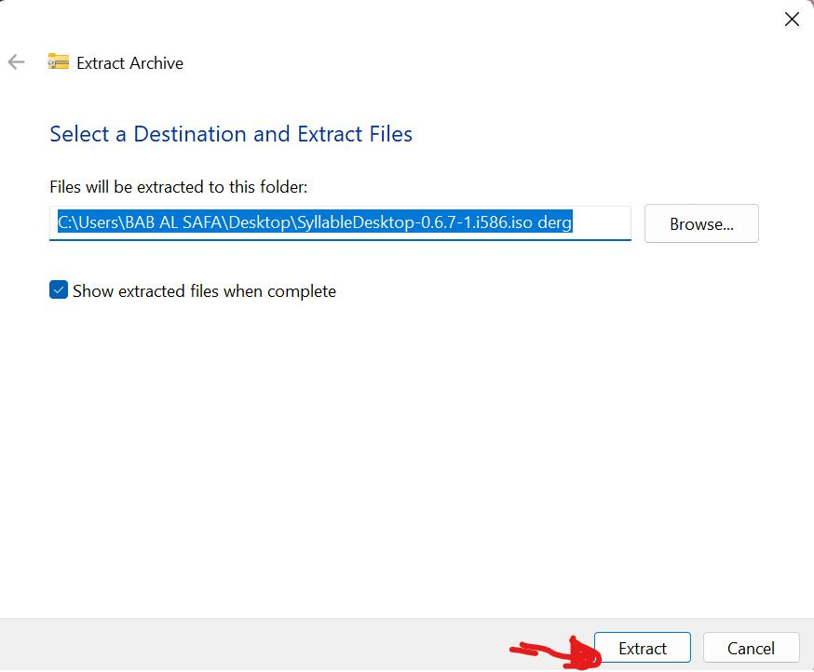  
  
 7-Zip started extracting the ISO, and I waited for it to complete.  
  
 Once the extraction was finished, I opened the folder extracted to examine its contents.

After that I Installed Syllable OS on VirtualBox

I opened VirtualBox and clicked on "New" to create a new virtual machine.

Named the virtual machine and selected the correct type (Other) and version (Other/Unknown). 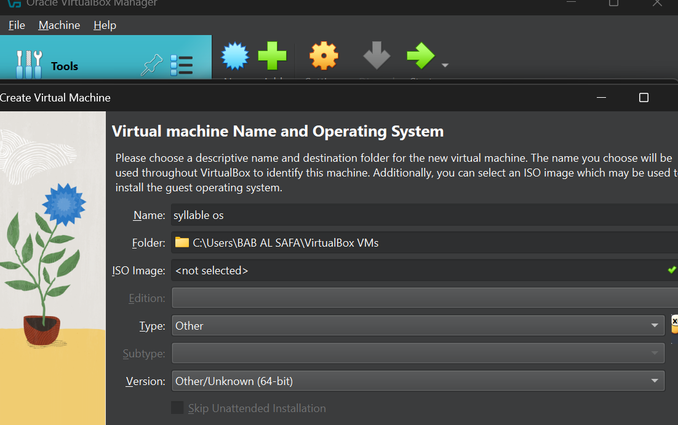

Allocated system resources:  
  
 Selected the amount of RAM 1024 MB .  
 Created a Virtual Hard Disk for storage.  
  
 I selected the Syllable OS ISO file to boot from.

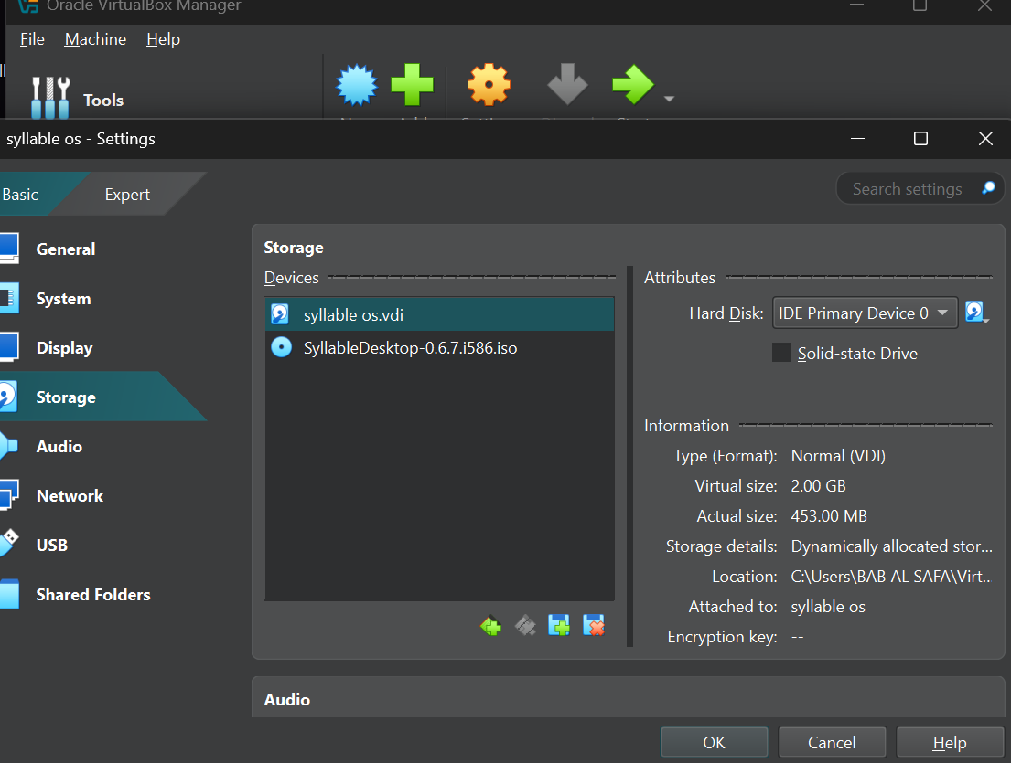

After that I booted the virtual machine, and installation of Syllable OS began.

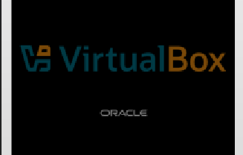

And I started installation process.

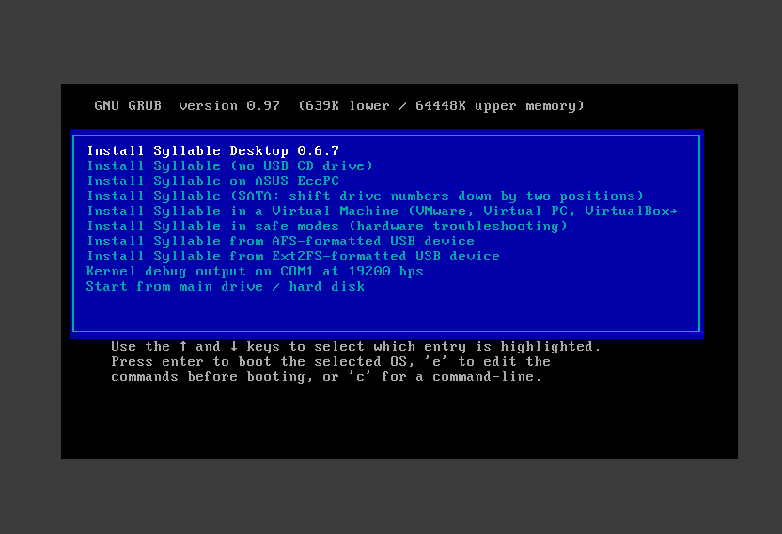

I proceeded through the prompts on-screen to complete the install:

Partitioned the virtual hard drive and I included the AFS extension during the installation process

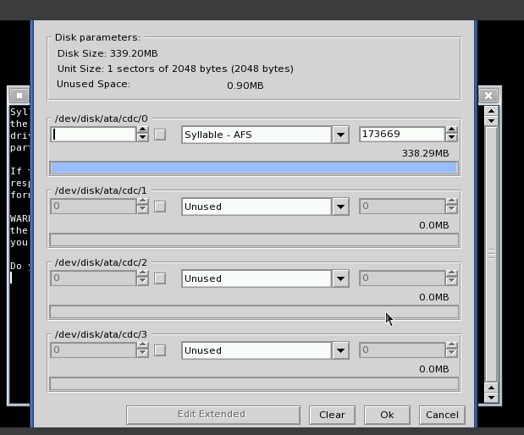

After including the AFS file, I pressed Enter, and a list of options appeared and I chose a.

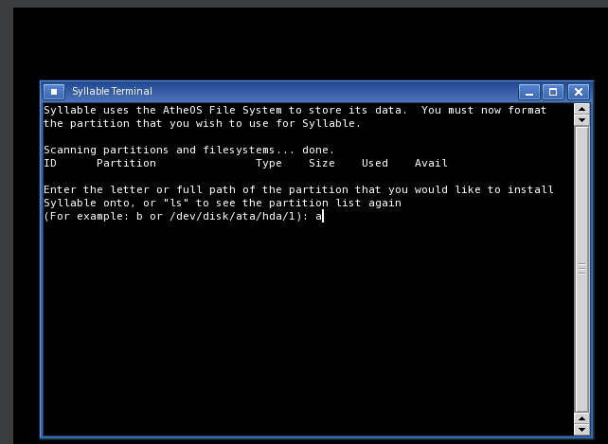

After pressing Enter, the installation process continued.

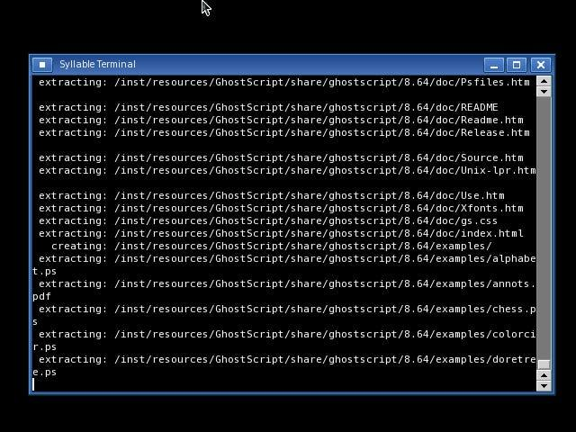

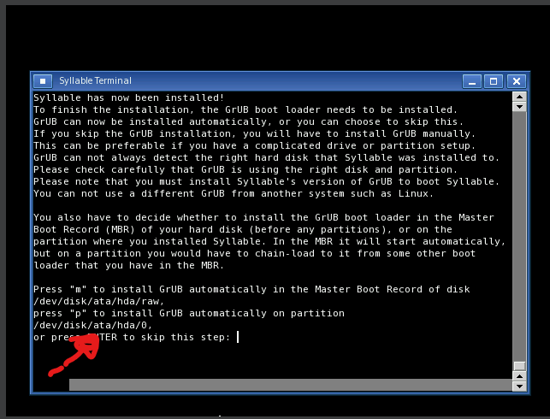

After that Once installed, I rebooted the virtual machine, and Syllable OS .

One limitation I encountered while installing Syllable OS was that the system is designed primarily for single-user systems and does not include inbuilt support to create additional **user accounts** or establish **password** protection processes.  
  
Syllable OS comes, by default, with two **user accounts**: "**root**" whose **password**is "**root**" and who has full admin rights, and "guest" whose password is "guest" and who has restricted rights. The system boots straight into the graphical desktop shell without prompt for user authentication, and hence there is no scope for creating individual user accounts or asking for login credentials at the time of installation.

After the installation process, when I reboot, the system automatically assigns a default password instead of letting me set my own.

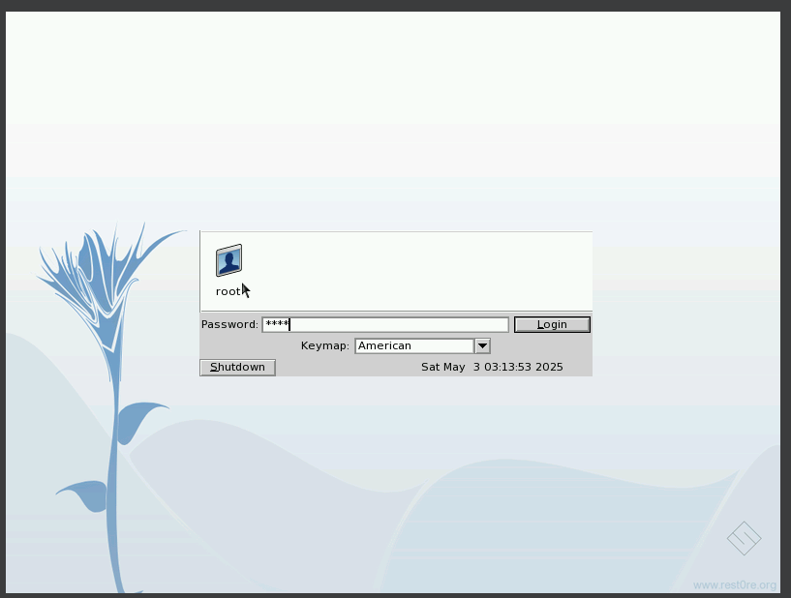

I enter the default password, fill in the login screen, and finally, I see the Syllable OS desktop.

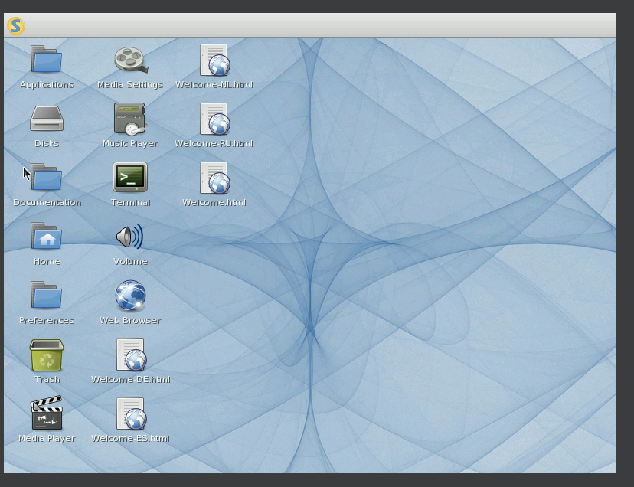

**e. Issues (problem faced):**

* lack of available information :

During the installation of Syllable OS, I encountered issues due to the lack of available information. The project has been marred by developer abandonment, internal conflicts regarding direction, and extended periods of inactivity, which led to fewer community members and fewer updates. Consequently, I struggled to find reliable resources. Google and YouTube provided no helpful references, and despite extensive effort and time, I could not access the necessary information.

* I also had an issue trying to get the recv() system call to work on Syllable OS. When I opened the terminal, instead of behaving like a code editor, it displayed only a black screen without any functionality. No pertinent information was present during installation that might rectify this problem.  
    
  I attempted a great deal on Google but was not able to find any solution. I even contemplated switching the operating system. I had already tried Arch Linux, but its installation was extremely complex. I was keen on proceeding with Syllable OS, but I could not install it successfully.  
    
  Now, I am considering trying another approach. I thought of transferring files from Syllable OS to Windows, but that also failed. I have attempted all the solutions I could think of. It has taken me over seven days to debug this issue, but with a lack of decent documentation and community support, I have not been able to resolve this.

**f. Solution :**

I conducted extensive research on Google and YouTube for information related to the issue, but I could not find any useful information. Most of the information I found was either outdated or incomplete.  
  
In an attempt to solve the issue, I employed several troubleshooting methods:  
  
 I manually attempted to debug the installation process.  
  
 I researched utilizing existing AI tools to assist in solving the issue.  
  
 I reviewed old forums and archived documentation for solutions.  
  
Despite these attempts, I was not able to fully resolve the issue. Lack of updated references and backing from the community made it very difficult to repair the issue.

***g. Filesystem support***

**i. Which filesystem support(NTFS, FAT32, exFAT, ext4, Btrfs, ZFS, HFS+, APFS) and why**

Filesystem Support in Syllable Os Syllable OS, an easy-to-use and lightweight operating system, offers support for several filesystems to enhance functionality and compatibility.  
  
  **Filesystems Supported:**

1. ext2/ext3/ext4 Filesystems  
Syllable supports ext2 and ext3, with ext4 being an alternative.

Why: These filesystems are popular among the Linux community, so they're a good fit for Syllable. Ext2 is basic and stable, whereas ext3 and ext4 have journaling capabilities that ensure data isn't lost. This is actually crucial to keep our system stable and our files safe.

2. FAT32  
Syllable can read and write to FAT32 with ease.

Why: FAT32 is essentially the filesystem universal language supported by almost all operating systems around. It's ideal for USB drives and external storage, enabling we to exchange files with ease. Just don't forget that it has a 4 GB limit per file, which may catch we out if we are working with big videos or backups.  
 3. exFAT  
Syllable is growing in its support for exFAT.

Why: This filesystem is great for flash drives and SD cards, especially since it  
supports files larger than

4. Btrfs  
Not natively included, but Btrfs can be used with some extra setup. Why: If we’re looking for advanced features, Btrfs is worth considering. It offers things like snapshotting and efficient data management, which can be very handy if we're serious about data integrity and recovery. It's great for users who want to experiment with new storage schemes.

5. NTFS  
Syllable has minimal support for NTFS.

Why: While NTFS is the default for Windows, it can be a little troublesome with Syllable due to its complexity. However, if we have to access NTFS drives, it can do so with some restrictions. This is handy for file transfers from Windows systems as required.

6. ZFS  
Normally unsupported in Syllable.

Why: ZFS is used in enterprise systems with its powerful features like checking data integrity and scalability. However, its power makes it unsuitable for regular Syllable users.

7. HFS+ and APFS  
In Syllable: limited or no support.  
Why: They are macOS-exclusive. While we could perhaps access HFS+ drives, APFS is somewhat too new and complicated for Syllable. So, they're not that useful if we're operating within Syllable.

**Summary**: **ext2**, **ext3**, and **ext4** are obviously our best bet for internal installations in Syllable OS. For external drives, **FAT32** and **exFAT**are superior due to their compatibility with other systems. Having knowledge of what our choices are can make all the difference we handle our data more efficiently and select the filesystem most appropriate for us, whether we are valuing stability, compatibility, or extra features.

***h. Advantage and disadvantage*.**

Pros and Cons of Syllable OS  
Syllable OS is a lightweight, open-source operating system designed for home and small office use. While it has some benefits, it also has some drawbacks that users need to consider.  
  
 **Advantages of Syllable Operating System**

Lightweight and Efficient: Syllable OS is optimized for performance, consuming very little in terms of system resources. It can be utilized effectively on old hardware, making it ideal for reviving old systems.  
  
 User-Friendly Interface:The OS contains a native graphical user interface (GUI) which is easyto use and friendly for users of varying technical proficiency.  
  
POSIX Compliance: Syllable OS is compliant with the POSIX standards, thereby easily being compatible with a great majority of existing software and making porting of applications from other Unix-like operating systems easy.  
  
Open Source: Since it is open-source, Syllable OS provides developers and end-users access to, alter, and redistribute the source code, which allows community-created and user specific development and alteration.  
  
Integrated Applications: It includes built-in applications like a web browser (Webster), email client (Whisper), and media player, and an environment ready to deploy in out-of-box distribution.  
  
 ***Disadvantages of Syllable Operating System***

Limited Hardware Support: Syllable OS supports many common hardware devices, such as video, network, and sound cards from popular brands such as Intel, AMD, 3Com, nVidia, and Creative. Syllable OS might notsupport new or exotic hardware devices, therefore potentially having limited compatibility with new machines.

No Support for Contemporary Filesystems: The OS does not have support for recent filesystems like exFAT, ext4, Btrfs, ZFS, HFS+, or APFS that are commonly used in contemporary computing environments.  
  
Abandoned Development: Syllable OS is an abandoned project, and development has picked up pace gradually over time. While it offers a unique and lightweight operating system, users should be aware that official updates and support are limited.  
  
Limited Availability of Software: There is limited precompiled software, and people may have to compile programs from their source code, which is a drawback for non-development personnel.  
  
Networking Restraints: Syllable OS supports Ethernet networking but does not support PPP and PPPoE protocols, potentially restricting use within some network architectures.  
  
  
 Syllable OS offers a lean and user-friendly environment suitable for older machines and users who would like to have a simple operating system. However, its limited hardware support, filesystem compatibility, and available software, combined with its suspended development status, might prove to be a drawback for users requiring a more modern and flexible computing platform.

1. **Future outlook/recommendation.**

**Future Outlook of Syllable Operating System**

Syllable operating system is an open source development that has established its niche as being userfriendly and POSIX-compatible.

Development and Updates

Syllable has been making solid progress, though it has not seen the same degree of updates as more widely used operating systems. For it to truly prosper, there must be continuous development and innovation vital. Ongoing updates not only make a difference to the functionality but keep users engaged.

***Community Engagement***

Community Participation a mature, healthy community may be an even more significant driver of growth. Encouraging input from developers and from ongoing users alike will be crucial. This entails making an inviting arena for exchange andcollaboration where all can sense their contribution is not insignificant.

***Hardware Compatibility***

Hardware Support For wider adoption, Syllable must increase support for newer hardware. To confirm compatibility with fresh hardware will cause it to become more appealing to customers who rely on latest technology.

Market Positioning

Syllable needs to consciously differentiate itself from competitors like Linux and Windows.Focus on its better features i.e., lightness and user-friendliness can allow fornicing a different niche within the operating system market.

**Recommendations**  
 Focus on Usability:mproving the customer experience lies at the root of it. This involves building  
intuitive interfaces and providing quality documentation to allow newcomers to be able to easily utilize the system.

Expand the Software Universe:Collaboration with developers to create and port software appropriate to varying user needs can help further increase Syllable's appeal. A solidly established software environment is essential in order to win and maintain users.

**Promote Awareness:**Better exposure through targeted marketing and savvy partnerships can help draw new users and developers. Share success stories and prove Syllable's benefits can address potential adopters.

**Prepare for a Learning Curve:**For those transitioning from more traditional operating systems, being ready for a bit of learning curve is important.

Syllable has its own unique interface and paradigms, which can take a while to get accustomed to. Placing an emphasis on support material can make this transition easier.

. **j**.**Conclusion**

The Syllable Operating System offers a desirable alternative to somebody looking for an easy-to-use, powerful, and lightweight computer experience. Upon a simplicity-based and performance-inspired foundation, the microkernel nature of Syllable not only enhances stability but also optimizes resource usage so that it is kept low, making it a prime candidate to run on legacy hardware. But for Syllable to dominate the competitive world today, several strategic steps are critical. Expanding its software base will be crucial—new applications can help attract a wider audience. Increasing hardware support is also critical; ensuring Syllable performs well with existing hardware will enhance its attractiveness. Creating a dynamic community is also critical. Talking to users and developers can lead to good contributions and a better ambiance. Also, adding new features and refining the user interface constantly will help retain existing users.

while drawing in newcomers. By actively pursuing the promotion of Syllable and addressing these key areas, the project can become a trusted alternative to commercial operating systems. It's particularly attractive to those who value efficiency and an uncluttered computing environment. With the right guidance, Syllable can develop and mature, having a positive impact in the bountiful world of open-source operating systems.

**2. Briefly explain the what, why, and how virtualization in modern**

**operating system.**

What:  
**Virtualization** in modern-day operating systems is an exciting technology that enables the creation of virtual replicas of physical resources. It provides the opportunity for multiple operating systems or applications to run on one physical machine at a time, maximizing efficiency and resource utilization. Virtualization basically involvesthe development of virtual replicas known as virtual machines (VMs). The process deploys the underlying hardware,  
streamlining management and assignment efficient use of computing resources.

**Virtualization** in modern operating systems is an effective method that significantly boosts efficiency, flexibility, and security in IT environments. As technology continues to evolve, virtualization is a core component that continues to drive innovation in cloud computing, enterprise resource planning, and application development. Through application of the technology, organizations are able to respond more effectively to changing requirements and streamline their IT infrastructure.

**Key Features of Virtualization**

Isolation: Each virtual machine is isolated, such that if one VM crashes, it does not impact others. This is essential both for security and stability.

Resource Management: Virtualization makes it possible to dynamically allocate CPU, memory, and storage between VMs. This optimization enables optimal utilization of hardware resources.

Snapshots and Cloning: VMs can be cloned or snapshotted easily, enabling instant backup points and recovery options. This is a feature that is priceless for testing new applications or disaster recovery.

Live Migration: One feature that stands out is the movement of VMs from one physical host to another without any downtime. This feature is specifically beneficial for maintenance and load balancing.

**Types of Virtualization**

Full Virtualization: the hypervisor simulates the whole underlying hardware, and unaltered guest operating systems may be executed (e.g., VMware ESXi).

Paravirtualization:the guest OS is modified such that it directly talks to the hypervisor, which can lead to improved performance (e.g., Xen).

OS-level Virtualization: This approach allows numerous isolated user-space instances, orcontainers, to be executed over a single OS kernel (e.g., Docker, LXC).

Hardware Virtualization: This method utilizes hypervisors like VMware, Hyper-V, or KVM to make VMs capable of their own operating system.

**Use Cases**Development and Testing: Test applications in numerous environments without incurring additional hardware costs, efficient development process  
Server Consolidation: Virtualization cuts down physical servers needed, reducing costs as well as power usage.

Why:

Virtualization has emerged as the backbone of current operating systems, providing abundance advantages that improve efficiency, flexibility, and security. The benefits of virtualization in modern operating systems are immense. They improve cost-effectiveness, security, and increase operational flexibility. With organizations working in an ever-evolving technology environment,virtualization is an essential element of effective IT infrastructure and cloud computing strategies. Through the use of this technology, organizations are equipped to handle future challenges and opportunities.

**Resource Optimization**

Maximum Hardware Utilization: Virtualization allows for the execution of multiple VMs on single hardware.  
run on a single physical server. This maximizes the use of available CPU, memory, and storage with minimal idle time and waste.

Dynamic Resource Allocation: Resources are readily modified on the fly as per the needs of each VM to deliver optimum performance to all applications.

**Cost Savings**

Lower Hardware Costs: With fewer physical servers needed, organizations can save their capital costs. That is, the capacity to run multiple applications on fewer machines, which is a twofold advantage.

Lower Operational Costs: Virtualization lowers power consumption, cooling expenses, and data center space, leading to cost savings in the long run.

**Improved Security**

Isolation of Environments: Each VM operates in its own isolated environment, and this makes security compromises in one VM not affect others. This is highly important for running untrusted applications or testing.

Easy Backup and Recovery: Virtual machines are easy to back up and restore. Snapshots allow for speedy recovery points, considerably making disaster recovery more efficient.

**Enhanced Flexibility and Scalability**

Fast Deployment: New VMs can be launched fast, enabling organizations to grow their resources up or down based on need without the hassle of physical hardware modifications.

Support for Multiple Operating Systems: Virtualization allows several operating systems to share a single hardware, cross-platform support and testing being enabled.

**Simplified Management**

Facilities for Centralized Management: Most virtualization platforms have facilities for centralized management that allow administrators to monitor and manage all VMs from a single location, simplifying things.

Automation: Tasks like provisioning new VMs and patch management can be automated, reducing administrative workload and freeing time for more strategic pursuits.

**Testing and Development**

Safe Testing Environments: Developers may create isolated environments in which to test new  
applications without destabilizing production system stability.

Continuous Integration/Continuous Deployment (CI/CD): Virtualization enables CI/CD practices by allowing fast setup of testing environments for new code, speeding up the development cycle.

**Disaster Recovery and Business Continuity**

Less Complex Backup Solutions: Virtual machines are backed up as images of the entire, which simplifies the backup procedure and allows for speedy restoration in the event of necessity.

Geographic Redundancy: VMs are copied in different geographical locations, ensuring business continuity upon hardware failure or disasters.

**How Virtualization Operates**

Virtualization is an innovative technology for modern operating systems that allows more than one virtual instance—known as virtual machines (VMs) to run on a physical machine. technology enhances use of resources, supports multiple operating systems, and simplifies administration.

Virtualization enhances use of resources, supports multiple operating systems, and simplifies administration with **VMs** and **hypervisors,**and thus it is essential in today's computing environments.

**1. Hypervisor**

At the center of virtualization is the hypervisor, or alternately called a virtual machine monitor (VMM). The software layer provides multiple VMs on a single physical host.

The hypervisor manages resource allocation and separates each VM from the rest.

**Hypervisor Types:**

**Type 1 Hypervisor (Bare-metal):**

Runs directly on the underlying hardware without a host operating system, managing  
VMs in a direct manner.

Examples: VMware ESXi, Microsoft Hyper-V, Xen.

Applications: Prevalent in enterprise settings for server virtualization and cloud computing.

**Type 2 Hypervisor (Hosted):**

Runs above a standard operating system, relying on it for resource management.

Examples: Oracle VirtualBox, VMware Workstation, Parallels Desktop.

Use Cases: Typically used for desktop virtualization and development.

**Key Functions of a Hypervisor:**

Resource Management: Allocates physical hardware resources like CPU, memory, and storage to each VM based on the requirement, utilizing them efficiently. Isolation: Provides a safe environment for each VM, separating one VM's activity from influencing others, which increases security and stability.

Abstraction: Abstracts the hardware underneath so that VMs can run various operating systems regardless of the physical configuration. Performance Optimization: Optimizes resource allocation dynamically to ensure that VMs get what they need to run effectively.

Snapshot and Cloning: Allows snapshots to be taken to record the state of a VM at a specific point, making it easy to recover and clone for testing or expansion.

2.Virtual Machines (VMs)

A Virtual Machine (VM) is software emulation of a computer. Each VM maintains an operating system and applications, drawing on the host machine's hardware resources.

**Properties of VMs:**

Isolation: Each VM is independent, so processes of one VM will not disrupt another, enhancing security and reliability.

Resource Allocation: VMs receive virtualized hardware resources from the host, which allows for efficient use.

Several Operating Systems: VMs make it possible to run several operating systems (e.g.,Windows, Linux, and macOS) on a single device, particularly useful for development and testing.

Portability: VMs may easily be moved between different physical machines, packaged in a single data file for easy transfer.

**The Way VMs Function:**

**1.Hypervisor Interaction**: VMs are managed by the hypervisor, distributing resources and manages execution.

**2.Guest Operating System:** Each VM runs a guest OS that communicates with virtualized hardware as if running on a physical machine, offering a native user experience.

**3.Resource Allocation**

Dynamic Management:

The hypervisor dynamically manages and allocates physical resources among the VMs, maximizing performance.

Overcommitment:

Resources can be overcommitted, i.e., VMs can be assigned more  
virtual resources than the physical hardware can supply, relying on the assumption that not all VMs will use all their allocation concurrently.

**4.Execution**

Abstraction Layer: The hypervisor offers an abstraction layer that allows VMs to run with no dependence upon the architecture of the physical server.

Execution Context: Every VM runs in its own execution context, with its own kernel and system resources, so it is possible to have multiple operating systems running at the same time.

**5.Management Tools**

Centralized Interfaces: Virtually all virtualization platforms include management tools which streamline VM deployment, monitoring, and management.

Automation: Provisioning, scaling, and resource allocation are more streamlined with automation capabilities.

DIAGRAM REPRESENTATION

